**Acknowledgment**

I would like to express my deepest appreciation to all those who provided me the possibility to complete this report.  A special gratitude I give to Mr. Sandesh R. S, Mr. Kendaganna Swamy, Mrs. Rachana S. Akki whose contribution in stimulating suggestions and encouragement, helped us to complete our project.

***Abstract***—

Home automation system achieved great

Popularity in the last decades and it increases the comfort and

Quality of life. In this paper an overview of current and emerging

Home automation systems is discussed. Nowadays most home

Automation systems consist of a smartphone and microcontroller.

A smart phone application is used to control and monitor the

Home appliances using different type of communication

Techniques. In this paper the working principle of different type

Of wireless communication techniques such as ZigBee, Wi-Fi,

Bluetooth, enocean and GSM are studied and their features are

Compared with each other so the users can choose their own

Choice of technology to build home automation system.

Literature survey

Many Authors designed home automation systems by using different technologies. By using GSM based home automation System we need to send message/make a call to control home appliances. It has more time delay and complex system. By using Bluetooth home automation system also, we can control all the home appliances. But the main disadvantage is Range. Some authors designed home automation using Wi-Fi. But in those designs, they implemented only ON/OFF functionalities.

In our design we implemented ON/OFF along with automated variation of light intensity and fan speed based on surrounding light intensity and temperature. Also, in our design we implemented automated table lamp which switches on when a person sits on the cushion. This design also detects when a person enters the room.

**Application**

* Home Automation, also often referred to as smart home technology provides homeowners comfort, convenience and energy efficiency by allowing them to control smart devices, often by an app on their smartphone.
* A part of the internet of things (Iot), smart home systems and devices often operate together, sharing consumer usage data among themselves and automating actions based on the homeowners' preferences.
* IOT comes in handy for physically challenged people as they can control home appliances such as lights, fans etc using their smartphones.
* While efficiency and conservation are certainly Iot benefits, its potential to have improved control over home security is a primary focus.
* Voice based home assistant supporting natural language.
* Smart locks and switches.
* **Convenience:**This can be considered as one of the main advantages of home automation using iot. You have the control of all your devices connected through iot. It makes it very convenient for you to have all the devices adjusted just through your phone. For example, if you forgot to adjust your thermostat in the morning before you left your house, you can adjust it from your office.

**System-Analysis**

The proposed system has three parts

* Automated light and fan –

Intensity of light and fan speed changes with change in surrounding light intensity and temperature respectively when a person enters. This also offers control over phone by user. This is achieved by making use of Arduino microcontroller, LDR, LED, IR Sensor, Bluetooth-module [HC-05], Adafruit, google-assistant, Mqtl server, DHT-11, LCD, ifttl.  
  
- Automated table lamp

Exclusive for the on and off of table lamp on detection of presence of a person on chair. This is achieved by using pressure sensor.

**Block-diagram**

Automated light system

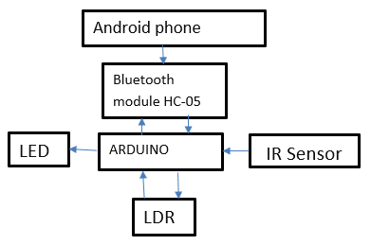

Automated table lamp

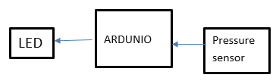

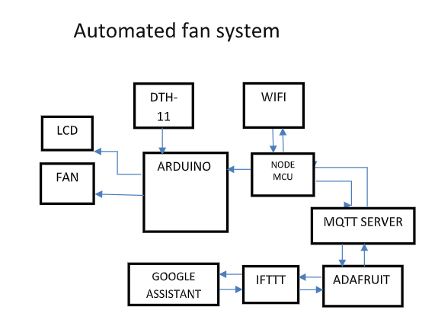

**LDR**:

A light dependent resistor works on the principle of photo conductivity. When light fall on the LDR, the resistance decreases. Resistance is inversely proportional to the light.

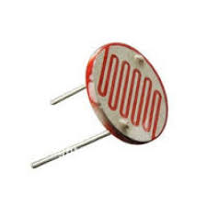

**ARDUINO**

Arduino is open-source electronics prototyping platform based on flexible, simple to use hardware and software. In simple terms, the Arduino is a small computer system that can be programmed with instructions to interact with different forms of input and output. ANDROID: Android is a software stack for mobile devices that include and operating system, middleware and key applications.

Pressure Sensor:

A **pressure sensor** is a device that senses pressure and converts it into an electric signal where the amount depends upon the pressure applied.

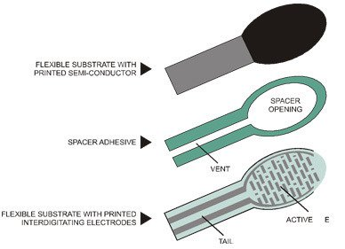

DHT11:

**DHT11** is a basic, ultra-low-cost digital temperature and humidity sensor. It uses a capacitive humidity sensor and a thermistor to measure the surrounding air, and spits out a digital signal on the data pin (no analog input pins needed). Its fairly simple to use, but requires careful timing to grab data.

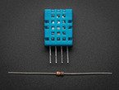

**Infrared sensor**

An **infrared sensor** is an electronic device, that emits in order to sense some aspects of the surroundings. An **IR sensor** can measure the heat of an object as well as detects the motion.

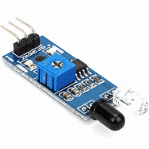

**Bluetooth module:**

* HC-05 is a Bluetooth module which is designed for wireless communication. This module can be used in a master or slave configuration.

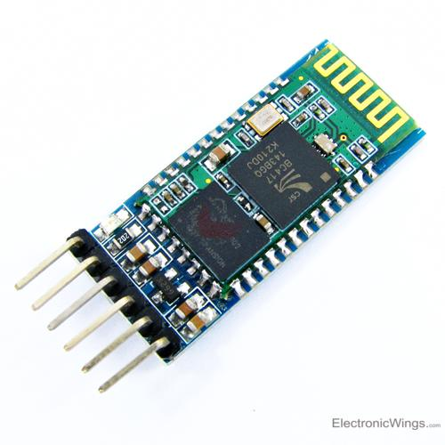

**MQTT:**

MQTT is a machine-to-machine(M2M)/"Internet of Things" connectivity protocol. It was designed as an extremely lightweight publish/subscribe messaging transport. It is useful for connections with remote locations where a small code footprint is required and/or network bandwidth is at a premium.

Adafruit.io:

**Adafruit**.**io** is a cloud service - that just means we run it for you and you don't have to manage it. You can connect to it over the Internet. It's meant primarily for storing and then retrieving data but it can do a lot more than just that!

IFTT:

**If This Then That**, also known as **IFTTT**, is a free [web](https://en.wikipedia.org/wiki/World_Wide_Web)-based service to create chains of simple [conditional statements](https://en.wikipedia.org/wiki/Conditional_(computer_programming)), called *applets*.

An applet is triggered by changes that occur within other web services such as [Gmail](https://en.wikipedia.org/wiki/Gmail), [Facebook](https://en.wikipedia.org/wiki/Facebook), [Telegram](https://en.wikipedia.org/wiki/Telegram_(messaging_service)), [Instagram](https://en.wikipedia.org/wiki/Instagram), or [Pinterest](https://en.wikipedia.org/wiki/Pinterest).

**[L293D Motor Driver:](https://www.instructables.com/id/L293D-Motor-Driver/)**

A **motor** driver is an integrated circuit chip which is usually used to control **motors** in autonomous robots. **Motor** driver act as an interface between Arduino and the **motors**.

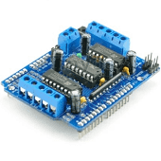

Node MCU:

It Connect Things EASY. An open-source firmware and development kit that helps you to prototype your IOT product within a few Lua script lines

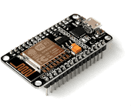

**Advantages**

* The proposed model not only offers on and off function but also the intensity of light and fan speed depends on surrounding light intensity and temperature respectively.
* The proposed system also detects when a person enters the room and the system switches on accordingly.

**Disadvantage**

* The system does not detect if the person leaves the room.   
  However, this can be overcome by using two IR sensors and modifying the code accordingly.
* Since the pressure sensor is localized pressure sensor cushion has to be modified with addition of spring to localize the pressure on the sensor.

**RELEVENCE**

* The chosen topic has its relevance to all the courses offered during 3rd semester
* ANALOG ELECTRONICS – 555 timers, microcontrollers, IC’s, filters, rectifiers, PLL
* DIGITAL CIRCUIT DESIGN – Encoders & Decoders for communication at transmitter and receiver ends, registers, GPIO pins, device drivers
* MEASUREMENT & INSTRUMENTATION – Sensors (PIR, DHT11, PROXIMITY, ULTRASONIC, IR), LDR
* SIGNALS AND SYSTEMS – The fundamentals of the course are used as a tool in various communication protocols, signal conditioning & sensing
* ENVIRONMENTAL TECHNOLOGY – efficient use of devices to conserve energy

Reference

[1] Atukorala K., Wijekoon D., Tharugasini M., Perera I., Silva C., (2009), “smart eye Integrated Solution to Home Automation, Security and Monitoring Through Mobile phones”, nextgeneration Mobile Applications, Services and Technologies, IEEE Third International Conference on, pp.64–69. [2] P. Siva Nagendra Reddy, K. Tharun Kumar Reddy, P. Ajay Kumar Reddy, Dr. G. N. Kodanda, Ramaiah, S. Nanda Kishor “An iot based Home Automation Using Android Application” International conference on Signal Processing, Communication, Power and Embedded System (SCOPES)-2016.

[3] Ravi Kishore Kodali, Vishal Jain, Suvadeep Bose and Lakshmi Bopanna Department of Electronics and Communications Engineering

National Institute of Technology, Warangal iot Based Smart Security and Home Automation System “International Conference on Computing, Communication and Automation (ICCCA2016)4}”

[4] Shopen Dey, Ayon Roy, Sandip Das. “Home Automation Using Internet of Thing”

[5] Kumar Mandula, Ramu Parupalli, CH.A.S. Murty, E. Magesh, Rutul Lunagariya Mobile based Horne Automation using Internet of Things(iot) 2015 International Conference on Control, instrumentation, Communication and Computational Technologies (LCCICCT)